CSY1018 Web Development assignment 1

# Background

Approximate hours spent: 20

The main reference that I used to create a running theme for the site was the work I did for my software engineering module, the team logo. I thought the red, grey and white theme would suit my online portfolio. It would look professional and still maintain the ascetics from the logo that I wanted to keep.

Other reference regarding themes and site structure are listed below:

1. <https://joel.sh>
2. <http://www.luiskonrad.com>
3. <http://www.mynus.sk>

reference one confirmed my belief that the colour scheme would look attractive yet professional. Reference two indicated that I would need an eye-catching homepage to attract potential employers, possibly simple homepage design and catchy title. Lastly reference three had an intricate grid system that I wanted to implement in my site as opposed to normal tables containing data.

# Design

To begin with I sketched a few ideas on a piece of paper just to get an idea of how I wanted the site to roughly look in both desktop and mobile variations, bellow is the cleaned up final sketch

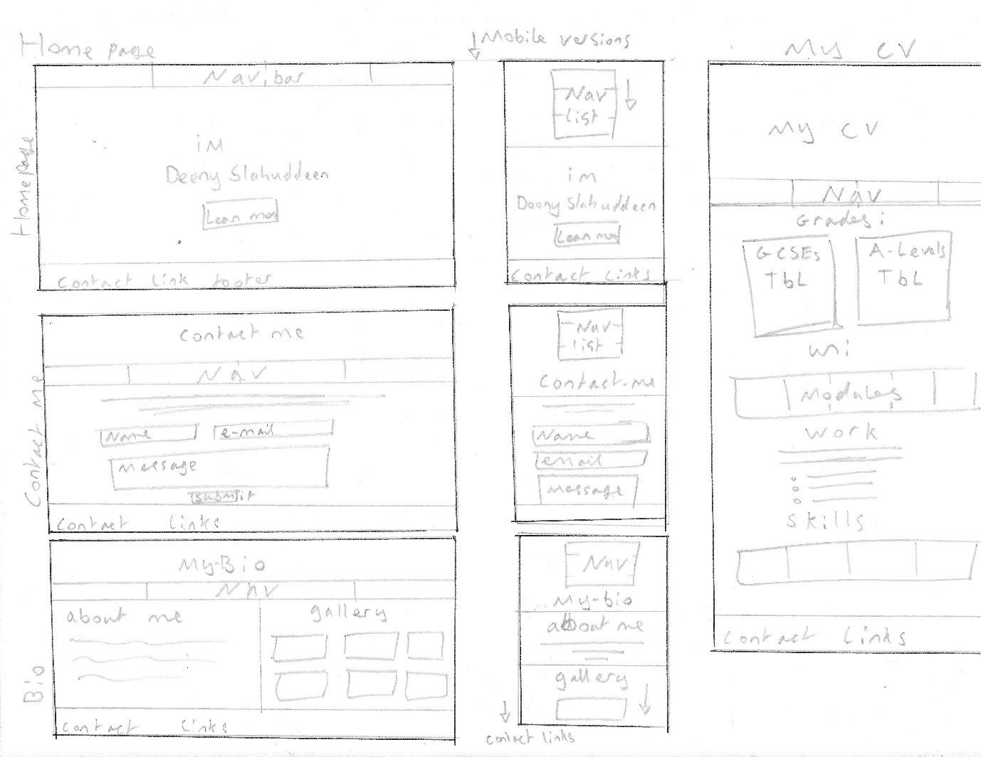

As seen there will be four pages, the homepage, my cv, my bio and contact me. These pages will be discussed further bellow.

## homepage

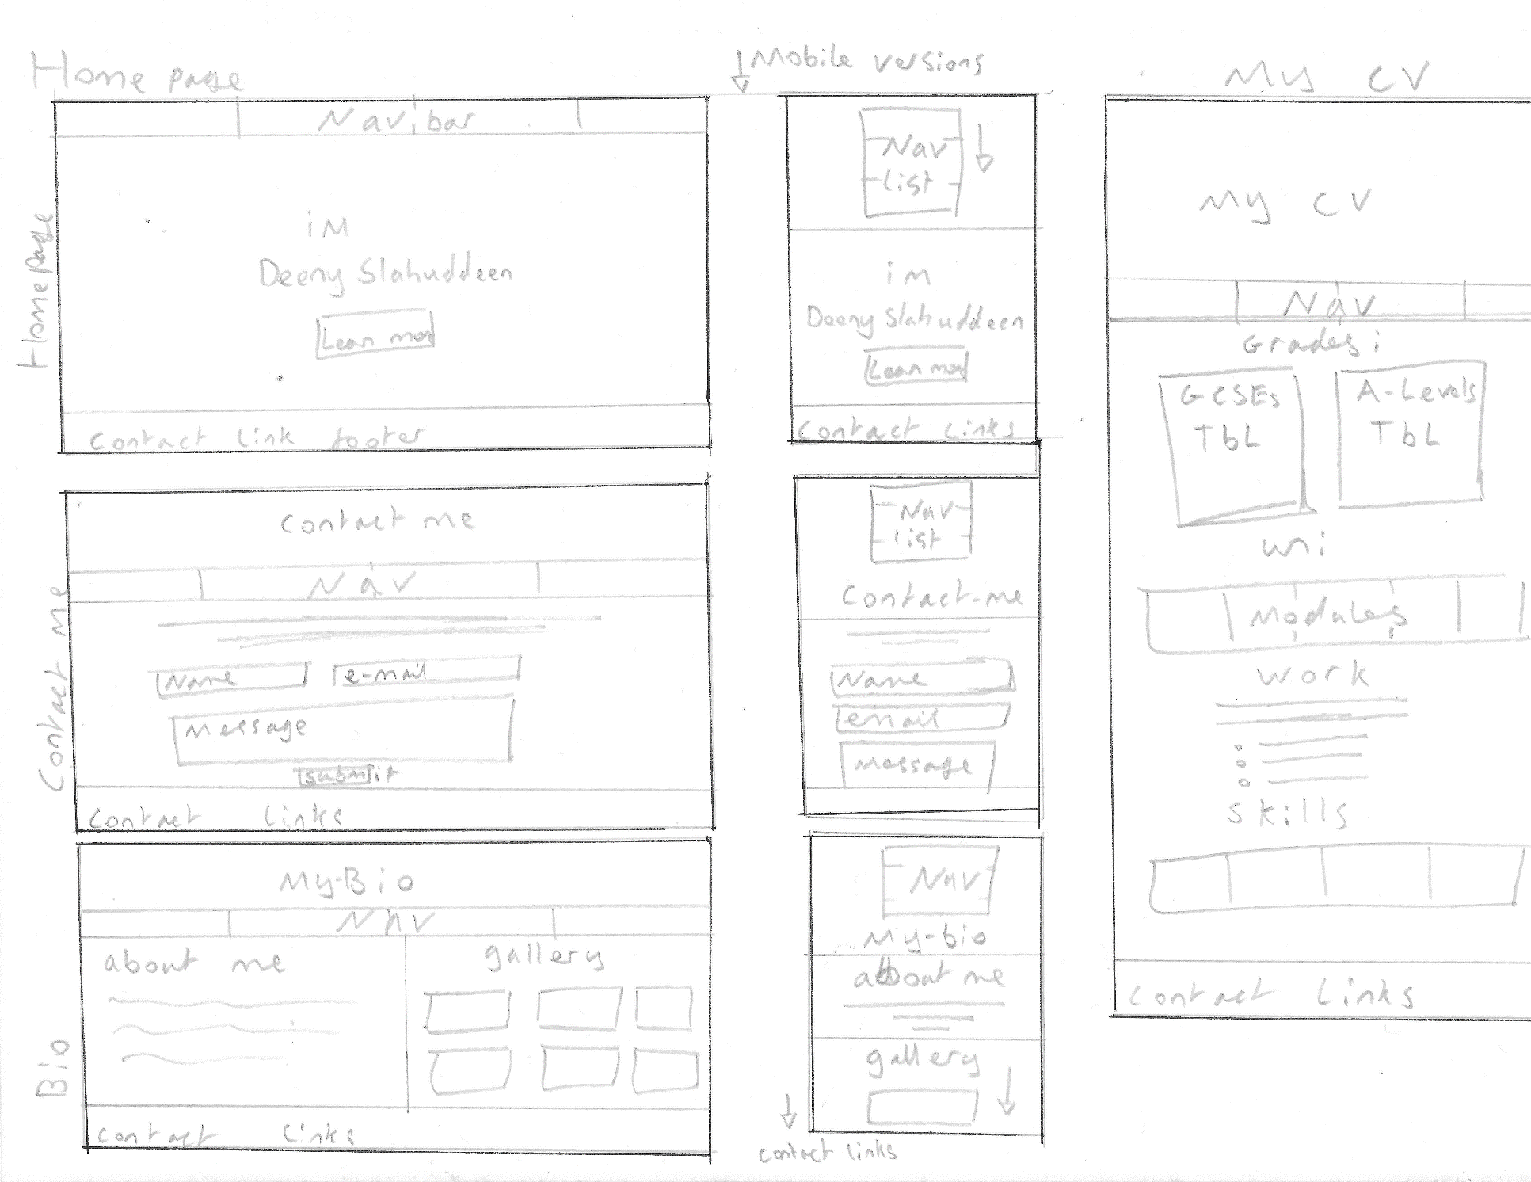

As stated in the references I wanted to make the home page as simple as possible, to draw the users attention to the centre of the screen, thus my name and the learn more button. Starting from the top we have the navigation bar, this will be a simple four button flexbox row but when in mobile mode it will turn in to a column for easier navigation on smaller screens. The titles themselves will have animations that will allow them to slide in from the left. The background will be an image I have taken in the past that represents myself and if possible will also be the same theme colour as the site. Lastly the footer will be a bar with all of my social media and GitHub/ CodePen links. If a user wants to contact me through them they are free to do so.

## Contact me

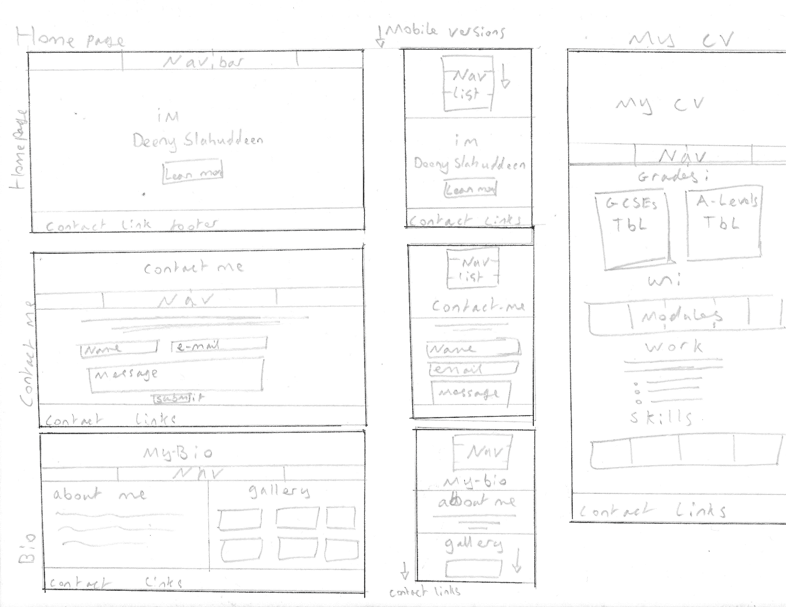

The contact me page will be of a similar style to the homepage. The header will contain an animated heading at the top centre of the page and a scrolling image in the background. Bellow that there will be the same navigation bar as the homepage with flex properties to allow it to still be functional on smaller screens. The contents of the page itself will be a basic form with some instructions for use. It will have name, email and message text fields as well as a submit button. The footer will again have the same contact links as the home page.

## My bio

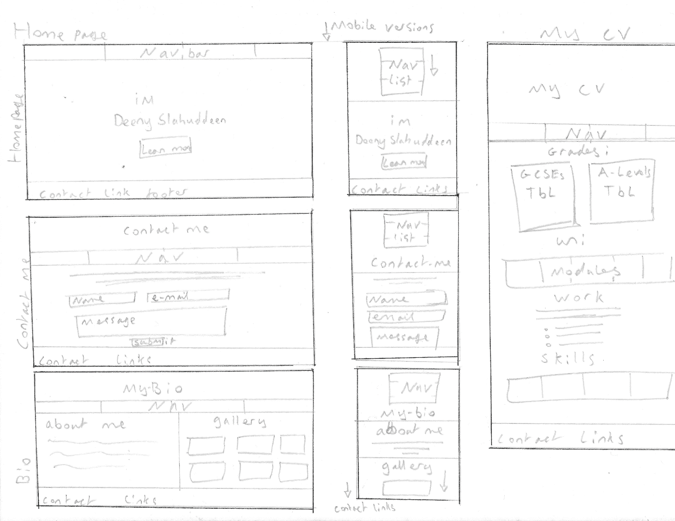

The bio page will follow the same style as the contact page. The contents will be split in two. The about me side will just have personal information about me and what I do outside programing and the gallery section will have images from my travels or experiences. If possible I will attempt to get the gallery to be interactive in some way (zoomable images).



## My CV

Lastly the cv page will have data from my actual CV, these will be grades, work experience and programing skills. It will also contain the university modules I am taking as a computing student. The grades will be contained within simple tables, however the university modules and skills sections will have custom built grid system that will looks similar to the tables ascetically. These grids will of course be flex boxed so they can adapt to when someone views the page on mobile.

## Test mock-up

finally, here is a mock-up done in Photoshop for how the basic homage would look. I think the red colour scheme is suitable here.

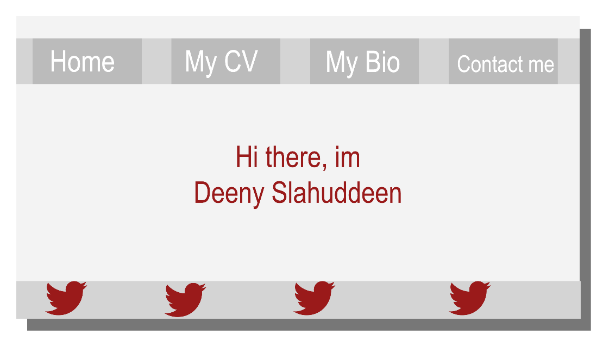

# Weekly progress

## Week1 (December 2nd)

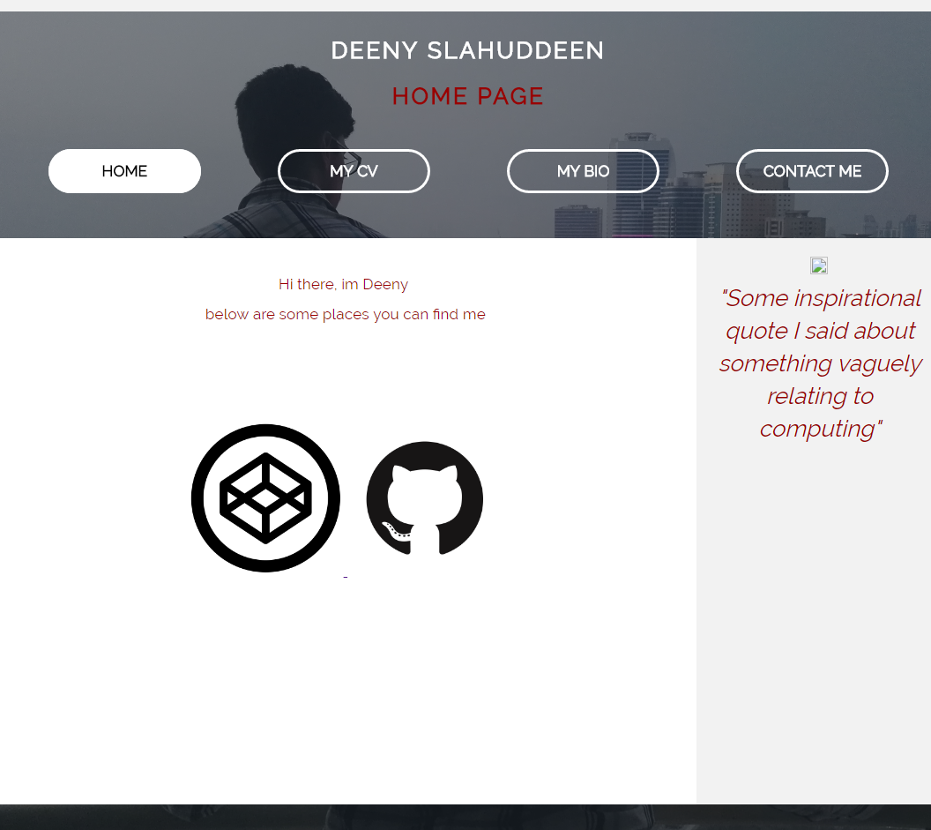

* Created the basic layout of the pages, have yet to complete the full homepage.
* Manages to get a scrolling background image (when scrolling down the background follows you)
* Headings are fully animated.
* Navigation bar looks better than expected after tweaking with the radius of the edges and making the centers transparent.
* Used google fonts and found Railway the default font for the site.
* Linked images to the GitHub and CodePen accounts.
* Flex box on the mobile version works with the nav bar, aside and main as well as the tables in the cv page.

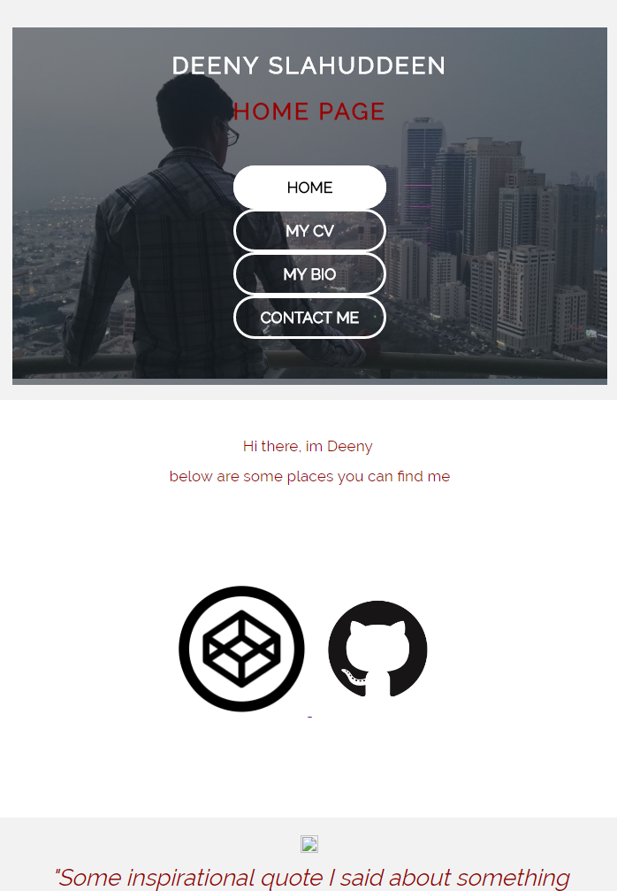

### Week 2 (December 7th)

* Optimised the CSS further

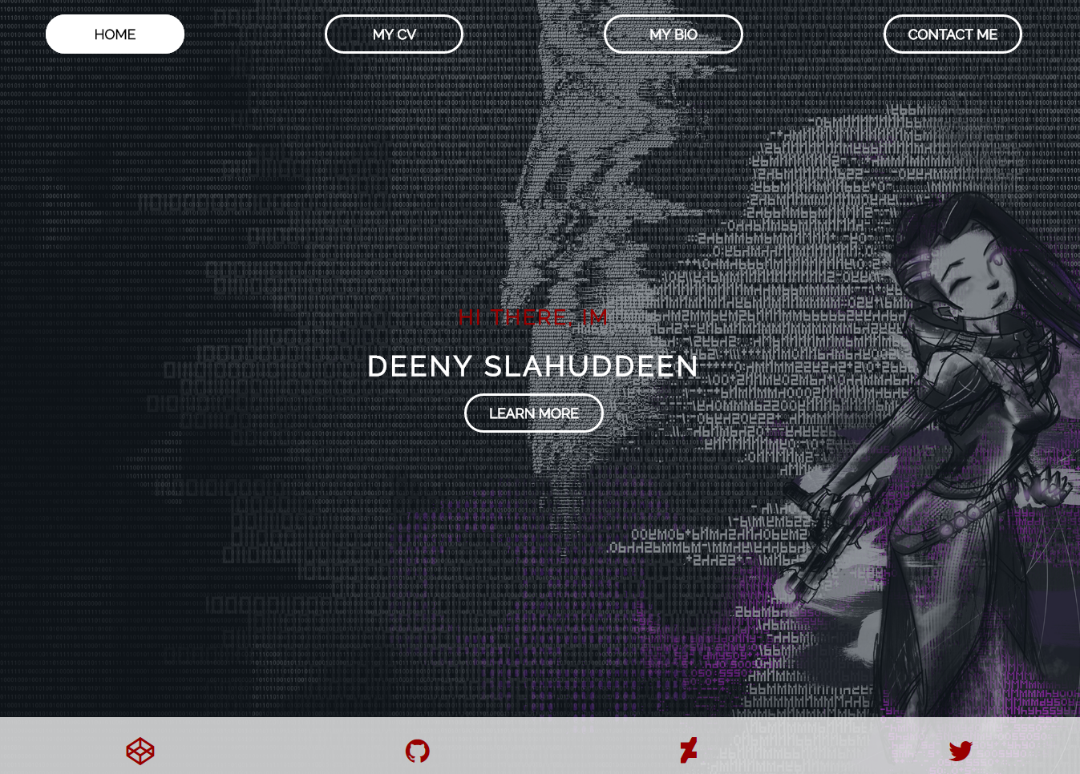

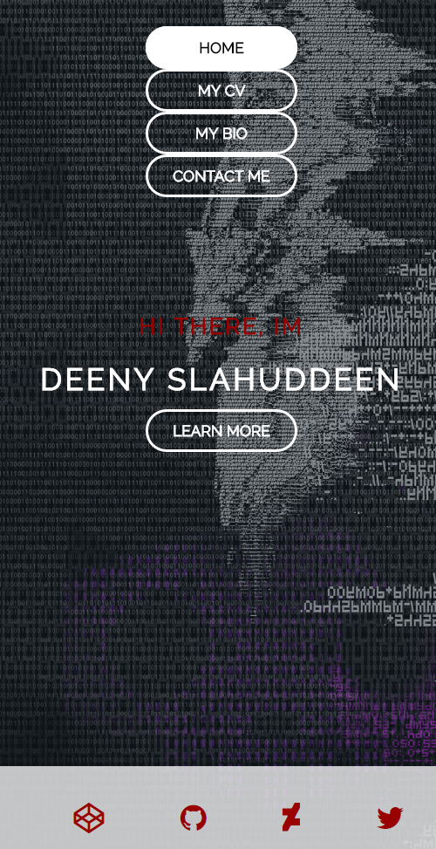

### Week 3 (December 22nd)

Homepage overhaul

* Changed the homepage to the desired style and added one of my own piece of art work as the background image.
* The images scale to fit whatever screen size, even in mobile mode.
* When hovered over the navigation buttons change colour.
* I’ve implemented font awesome for the contact links at the bottom of the page. I also added my deviant art and twitter links.

## Week 4 (December 28th)

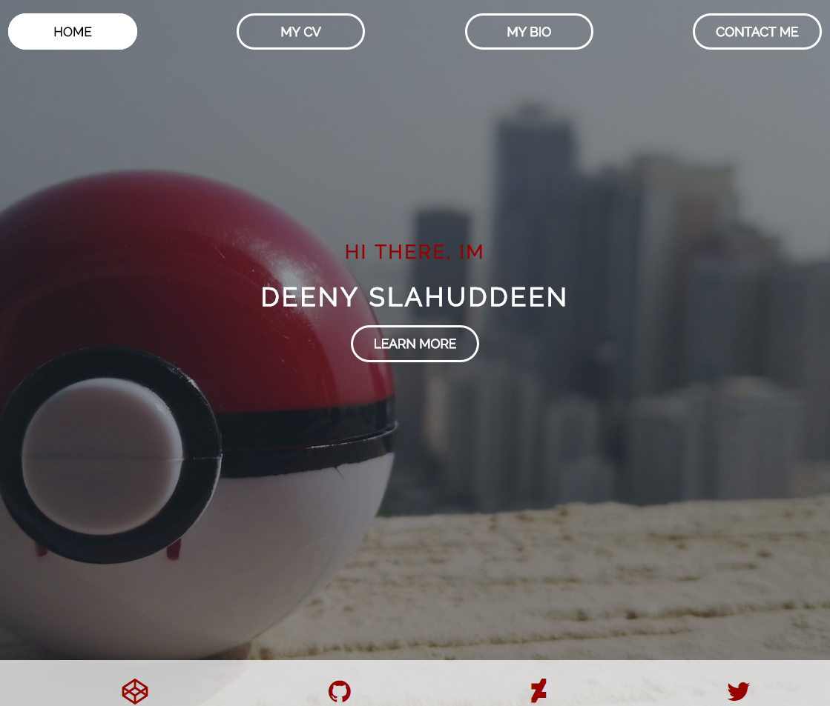

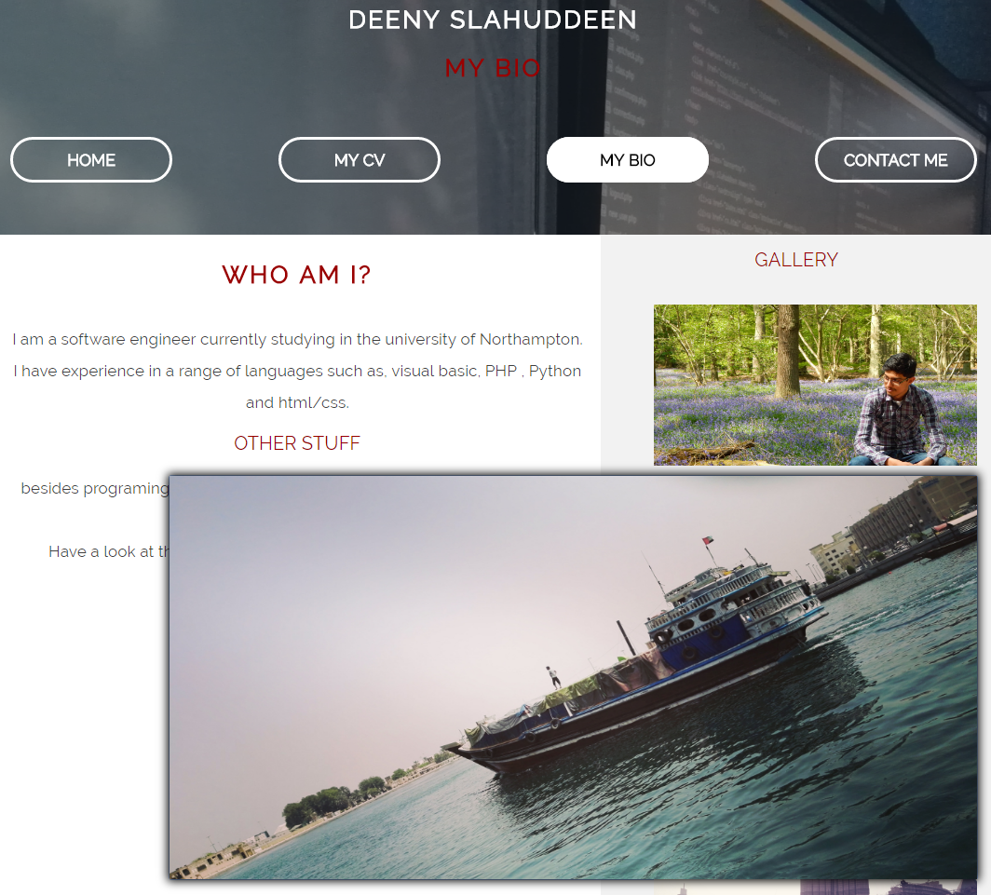

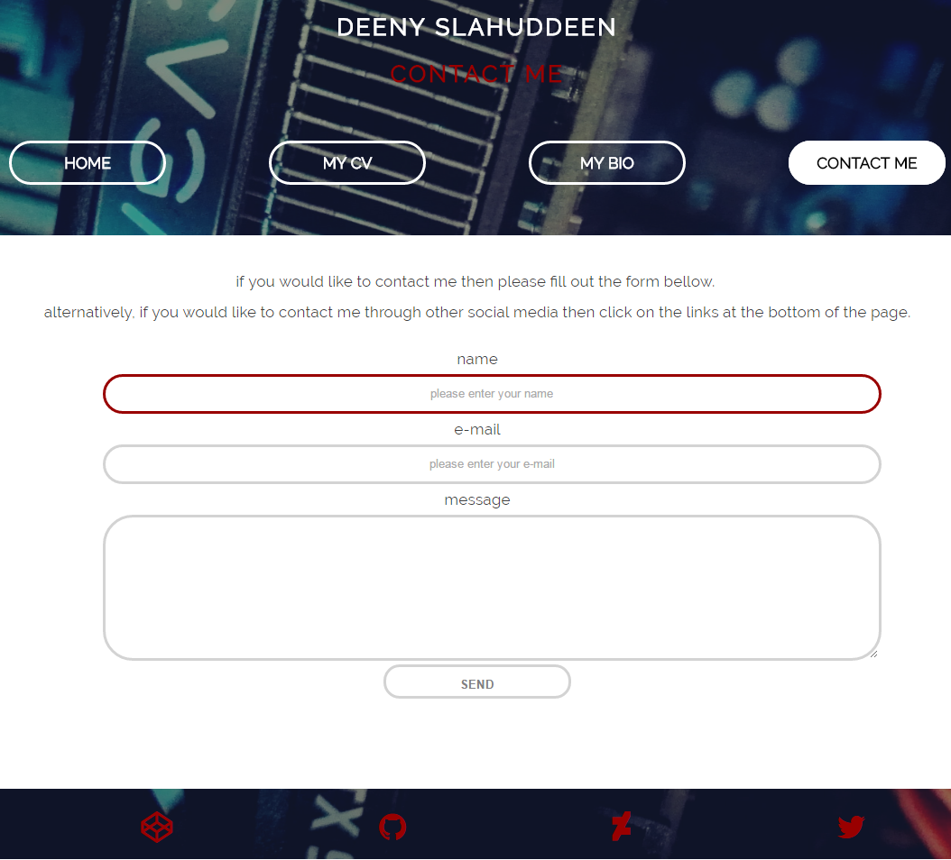

* Finalised the background image for the homepage.
* Implemented the grid system for the cv page. Fully flexbox compatible.
* Implemented the gallery in the bio page.
* Images are zoomable on click
* The contact form is complete and skinned to my sites theme.

### December 29th

* Optimised images to a smaller files size.
* Cut down irrelevant or redundant/repeating code
* Added comment code to all pages including the stylesheet.

# Evaluation

I believe the project has gone according to plan and that the end product is a fully functioning site.

The positives include:

* A functional gallery system.
* My own table/ grid system
* Aesthetic scrolling headers and animated headings.
* Nicely skinned forms and overlay a good looking site.

## Improvements include:

* The grid system could use some work to look more dynamic.
* The footer could use improvement to stop it from sliding up the page when there is no content there.

# Sources:

All images on the site belong to me, I have either created them or photographed them.

1. Coulter Smith, L. (2016) Flex layout example. Available at: <https://codepen.io/lizcoultersmith/pen/xEoYQv> (Accessed: 29 December 2016).

2. Rose, T. (2016) Animation example template. Available at: <http://codepen.io/UoN-ThomasRose/pen/rWYOve> (Accessed: 29 December 2016).

3. Rose, T. (2016) HTML form example. Available at: <http://codepen.io/UoN-ThomasRose/pen/NbYrGj> (Accessed: 29 December 2016).

4. Rohde, M. (2011) How to create an image gallery using CSS3. Available at: <http://www.htmlgoodies.com/html5/css/how-to-create-a-css3-based-image-gallery.html#fbid=qc338OaHV8V> (Accessed: 29 December 2016).